STEP 1:
I created a Virtual Private Cloud (VPC) to build a secure network for my project.
• IPv4 CIDR Block: 20.0.0.0/16 (gives enough IP addresses for all resources)
• Tenancy: Default (uses shared hardware) This VPC is the base for all other components like subnets, EC2 instances, and the RDS database.
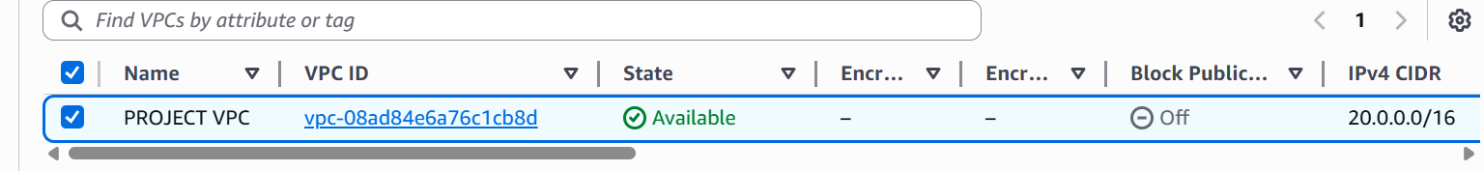
STEP 2:
I created 6 subnets in total — 2 public Webservers, 2 privates for application servers, and 2 private servers for the RDS database.
• Public Subnets: Connected to the internet using an Internet Gateway.
• Private Subnets: Connected to the internet only for outbound traffic using a NAT Gateway.
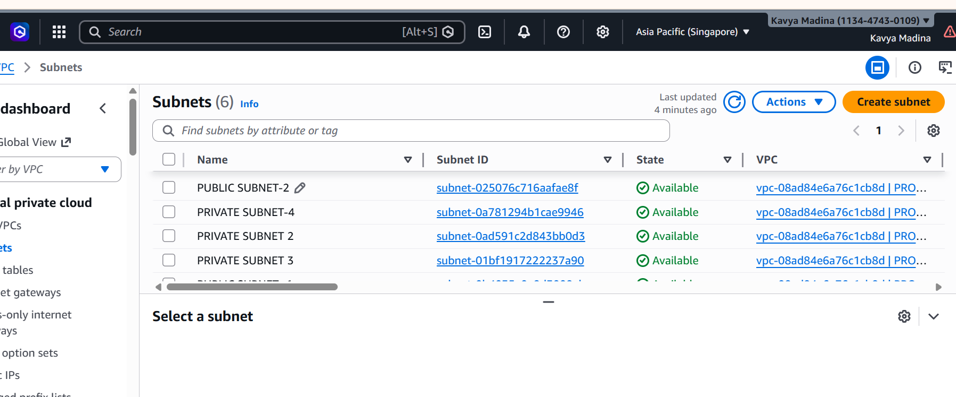
Step 3:
Create Route Tables
I created 2 route tables to manage network traffic between subnets and the internet.
•PUBLIC ROUTE TABLE: Connected to the internet using an Internet Gateway for direct access.
•PRIVATE ROUTE TABLE: Connected through a NAT Gateway for secure outbound access only (no direct inbound access). Each route table is linked to its respective subnet to ensure proper communication and security across the architecture.
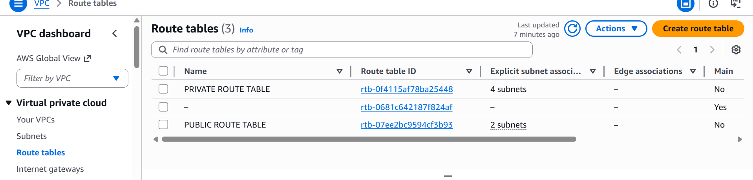
Step 4:
Create Internet Gateway and NAT Gateway
I created an Internet Gateway to enable internet access for public resources.
• Attached it to the VPC to allow external connectivity.
• Linked it to the public route table so that public subnets (like the jump server) can send and receive traffic from the internet. This setup ensures that only the public-facing components have direct internet access, keeping private resources secure.
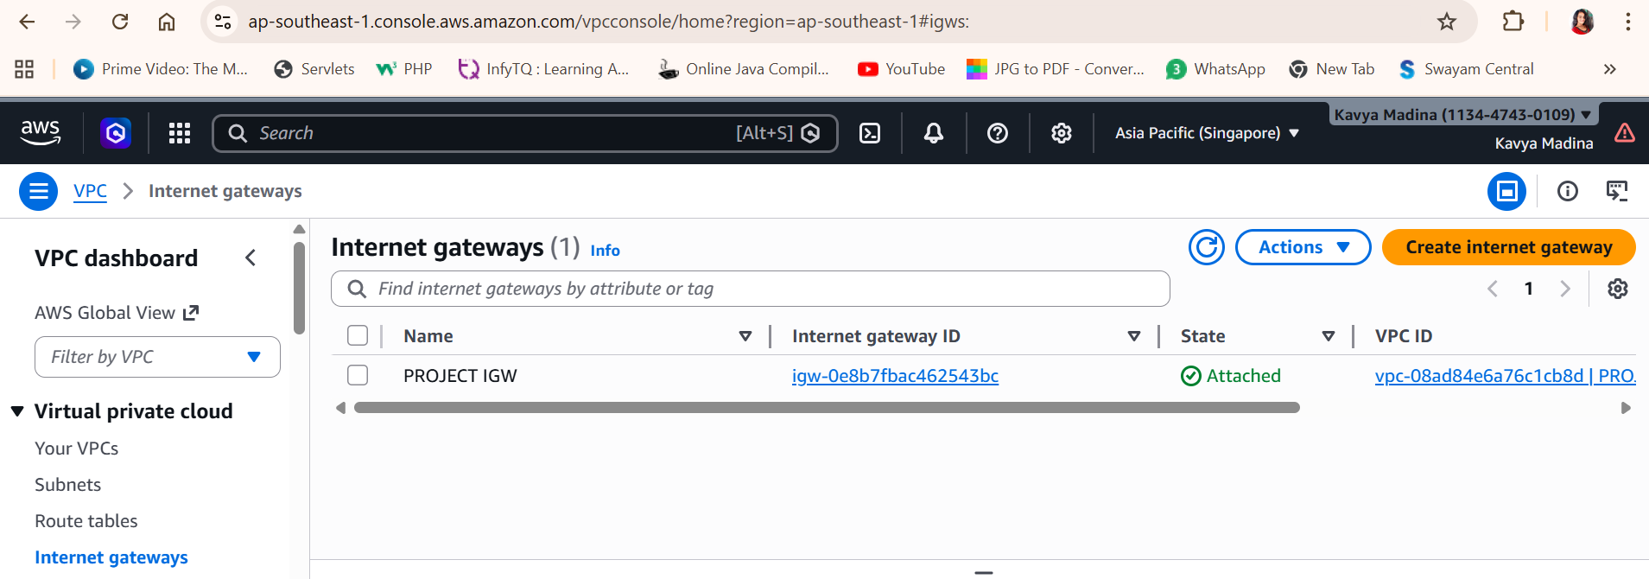
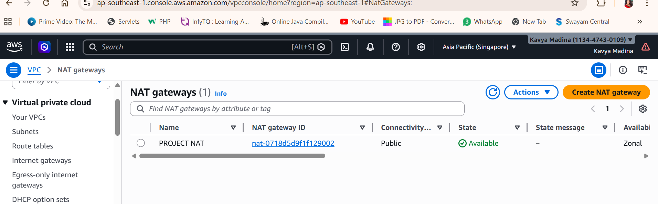
To validate all connections under your VPC and ensure the resource map is correctly configured
Step 5:
Create Security Group
I created Security Group to protect EC2 instances by controlling network traffic.
- Inbound Rules: Allow access only from trusted sources (e.g., SSH from my IP to public server).
- Outbound Rules: Allow EC2 instances to send traffic as needed (e.g., to the internet or RDS). This setup ensures that: - Public EC2 (Jump Server) is accessible securely.
- Private EC2 and RDS are protected and only reachable through the jump server.
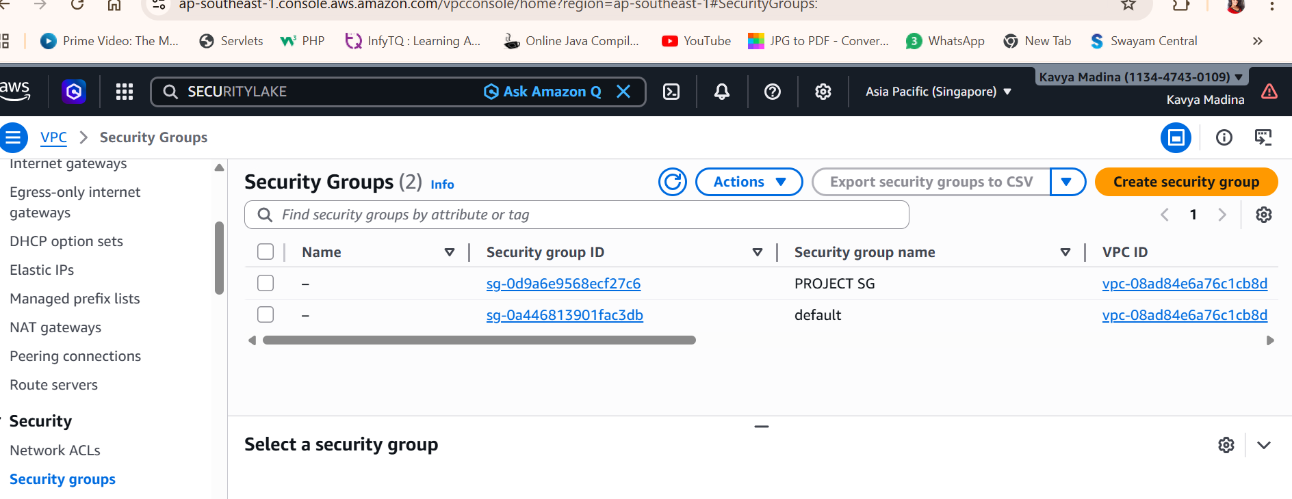
Step 6:
Launch EC2 Instances
I launched 4 EC2 instances across different Availability Zones for high availability and fault tolerance.
• 2 Public EC2 Instances (Jump Servers): o Deployed in Availability Zones 1a and 1b o Used to securely access private instances and RDS
• 2 Private EC2 Instances (Application Servers): o Also Deployed in Availability Zones 1a and 1b o Not directly accessible from the internet; accessed only through the jump servers This setup ensures secure access and load distribution across multiple zones.
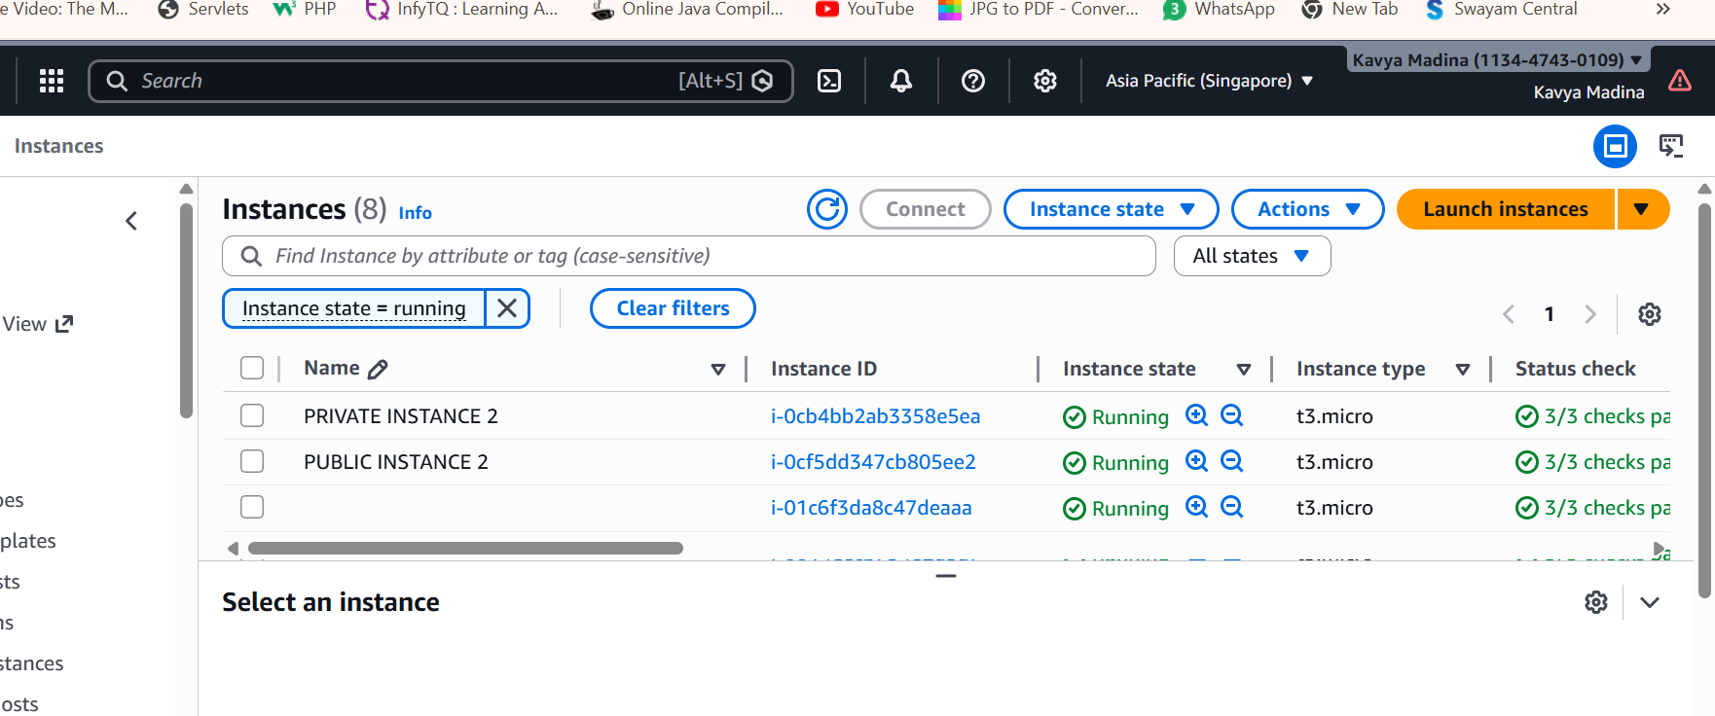
Step 7: Create Target Groups
I created Target Groups to organize EC2 instances based on their Availability Zones.
• Each Target Group includes EC2 instances from a specific zone (1a and 1b).
• These groups are linked to the Load Balancer, which distributes incoming traffic evenly across the instances. This setup helps balance the load and ensures high availability across multiple zones.
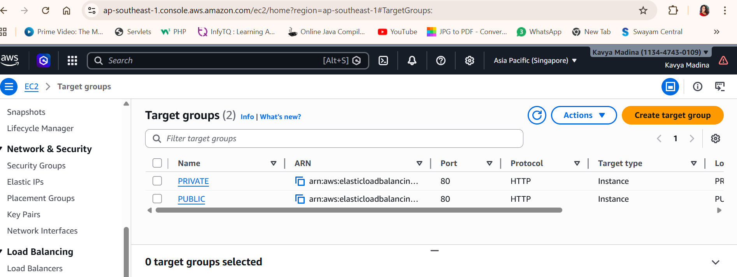
Step 8: Set Up Load Balancers
I created 2 Load Balancers to manage traffic:
• Public Load Balancer: Handles traffic from the internet and forwards it to the jump servers • Private Load Balancer: Manages internal traffic between application servers and the RDS database. Each Load Balancer works in its own Availability Zone (1a and 1b) to keep the system running smoothly and reliably.
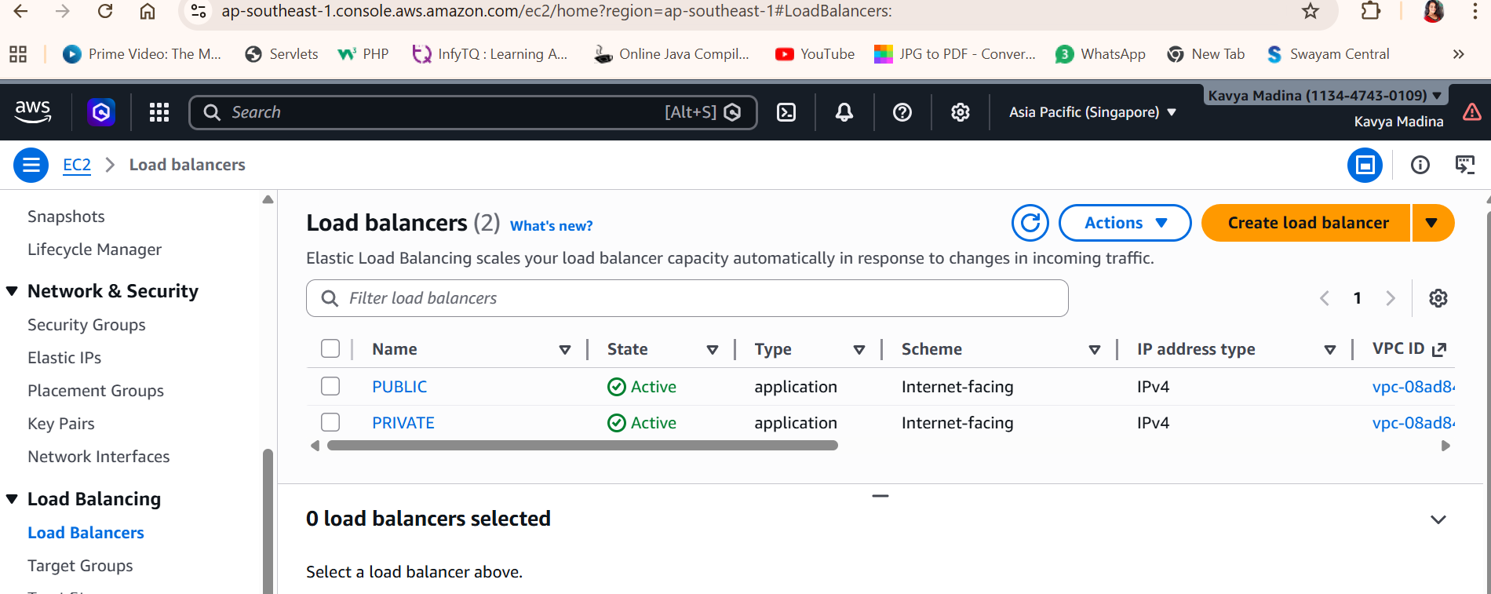
Step 9: Create AMIs for Auto Scaling
I created Amazon Machine Images (AMIs) from my EC2 instances.
• These AMIs store the configuration and setup of my servers.
• I used them to attach to Auto Scaling Groups, so new instances can launch automatically with the same setup when needed.
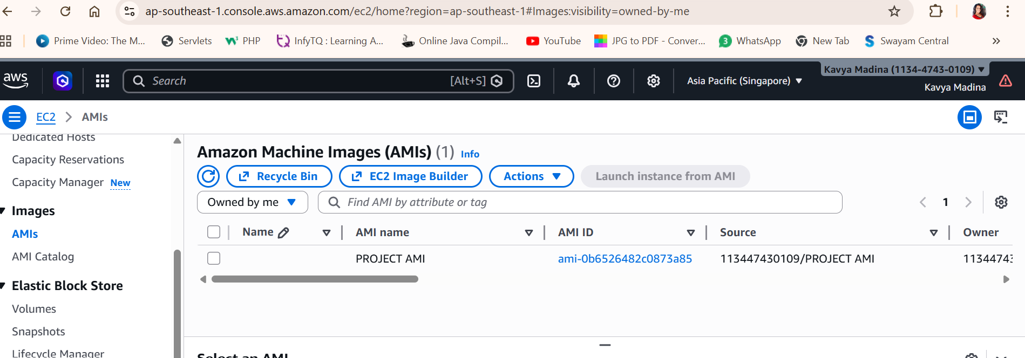
Step 10: Create Auto Scaling Groups
I set up 2 Auto Scaling Groups to manage EC2 instances automatically:
• Public Auto Scaling Group: Handles jump servers and keeps them running based on demand.
• Private Auto Scaling Group: Manages application servers and scales them as needed. This helps maintain performance and availability by adding or removing instances automatically.
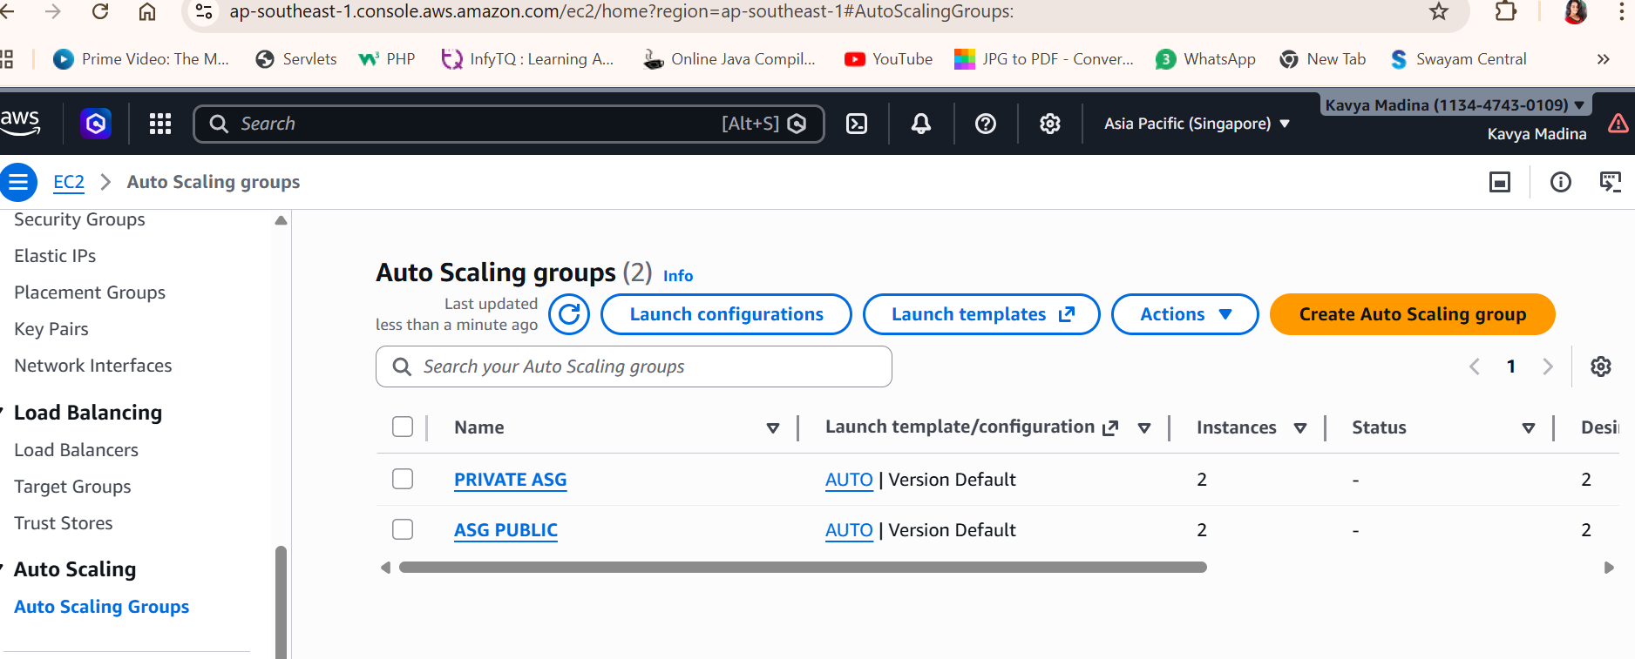
Step 11: Set Up Subnet Groups and Databases
• I created Subnet Groups in Availability Zones ap-southeast-1a and ap-southeast-1b to support database deployment.
• Then, I launched 2 RDS Databases — one in ap-southeast-1a and one in ap-southeast-1b
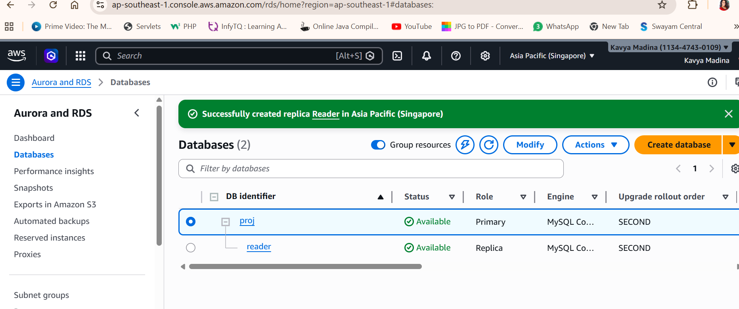
Step 12: Verify Connectivity I tested the network setup to make sure everything works as expected
• Accessed the MySQL database from both public and private EC2 instances.
• Verified the database version to confirm successful connection.
• PUBLIC INSTANCE 1(in availability zone 1a) was used to securely connect to the private resources. This confirms that the VPC, subnets, route tables, and security groups are correctly configured for secure and functional access
